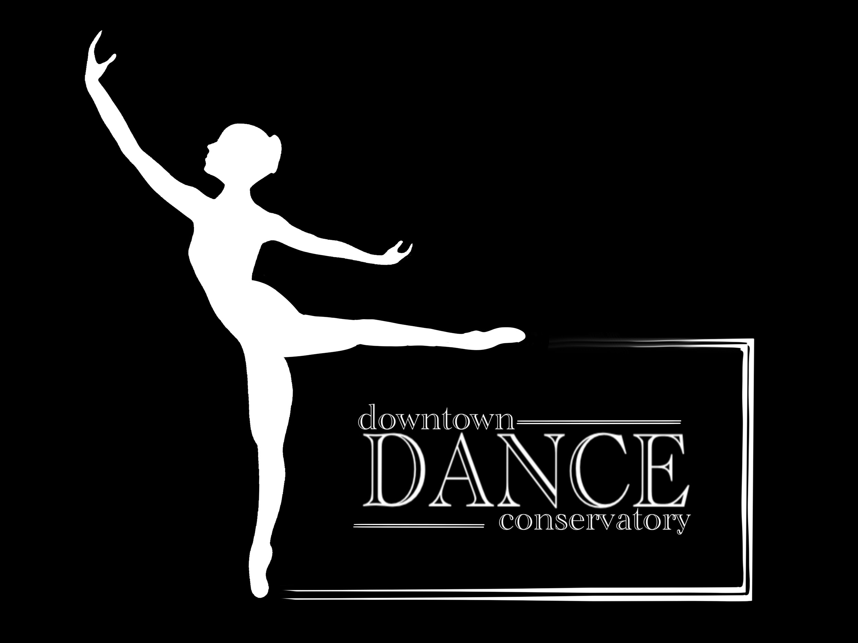
Adopt a dancer
Donation form

Donation Form Name of Donor:_________________________________________
or Name of Business (if applicable)_______________________________________

Donated Amount: $______________
- Check
- Cash

Where would you like the donation be used toward?

- Adopt - a - Dancer Program
- Current Adopt - a - Dancer Student(s)*
- Studio

*If Current Student is selected, please write the name(s) of donation recipient(s). ___________________________________ ____________________________________ ___________________________________ ____________________________________ ___________________________________ ____________________________________ Please attach this form to your donation and mail/bring in to: 700 E St Louis Ave, Las Vegas NV 89104. Expect a call from the Artistic Director within 2 weeks of your donation Make checks payable to Downtown Dance Conservatory If you have any questions feel free to contact us 702.637.0500 THANK YOU SO MUCH FOR BEING APART OF WHAT WE ARE DOING AT DDC!

